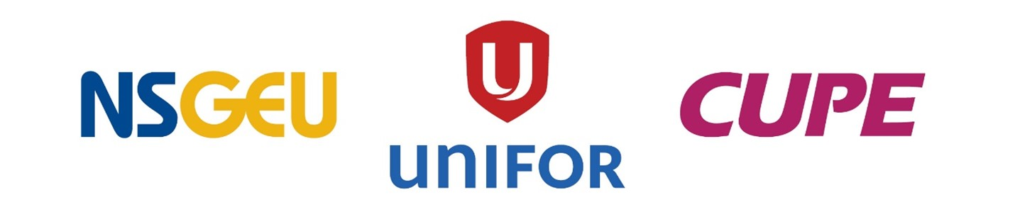
Health Care Council of Unions
Tentative Agreement Accepted

Dear CUPE member,
Members of the Health Care Council met with legal counsel this afternoon to tally your ratification vote, and the results are as follows: with 4,298 members in the bargaining unit participating, 79% voted to accept the agreement, as recommended by the committee.
We are very pleased to have concluded this challenging round of bargaining, and to have achieved a much-improved collective agreement for you and your colleagues in the Health Care bargaining units at Nova Scotia Health and IWK. The language achieved in this round of bargaining is significant, in that it clearly recognizes you should be leading in Atlantic Canada.
We appreciate the engagement, support, and solidarity demonstrated by the membership throughout this round and look forward to engaging members in our next round of collective bargaining, which will start well in advance of the expiry of the collective agreement on October 31st, 2025. Our efforts to conclude an essential services staffing agreement continue via the Labour Board, as we are trying to ensure we don’t have to start that process over again when negotiations for your next round of bargaining begin again.
In the meantime, we will push to get the contract signed by all parties so the employer can begin entering the data into their payroll system so that you get your retro pay as soon as possible. We will update you on the status of essential services as that process moves forward.
If you have questions or concerns about the process, please contact your Area VP.

