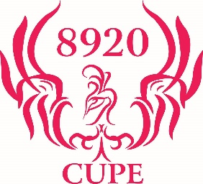
CUPE LOCAL 8920
Annual General Meeting
9:00 am to 5:00 pm May 2nd2020
Oak Island Resort & Conference Center
36 Treasure Dr, Western Shore, NS B0J 3M0
1-800-565-5075
info@oakislandresorts.ca

Name:
Email Address
Phone Number
Area:
Who is your Area VP_____________________________
Do you have any special food allergies? Please list if any

Do you require a room
Do you consider yourself a worker with disabilities?
If yes then do you have any special requirements? Please list if so

Please forward to cupelocal8920@gmail.com
Deadline for registration is March 25th2020

